A BREAK FROM THE CAFETERIA:

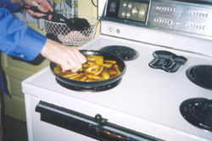

Come to The Augustana Vegetarian Society’s Fourth Annual
Pre-Finals Dinner!

Sunday, Nov. 13, 5-6 pm, Andreen Basement

All You Can Eat for JUST $3!
($4 at the door)

Plus…
- Win door prizes
- Watch episodes of The Simpsons
- Take a healthy (and fabulously delicious) break from studying for finals
- Did we mention that we’re fabulous cooks?

