These people look happy!

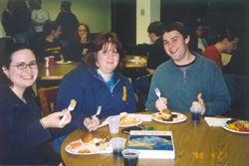

You can be happy, too!!!!!

Come to the Fourth Annual Augustana Vegetarian Society

Pre-Finals Dinner!

Sunday, Nov. 13th, 5-6 pm, Andreen Basement

All-you-can-eat for $2
($3 @ the door)

Plus…
- Win door prizes
- Watch Simpsons Episodes
- Did we mention that we’re fabulous cooks?

