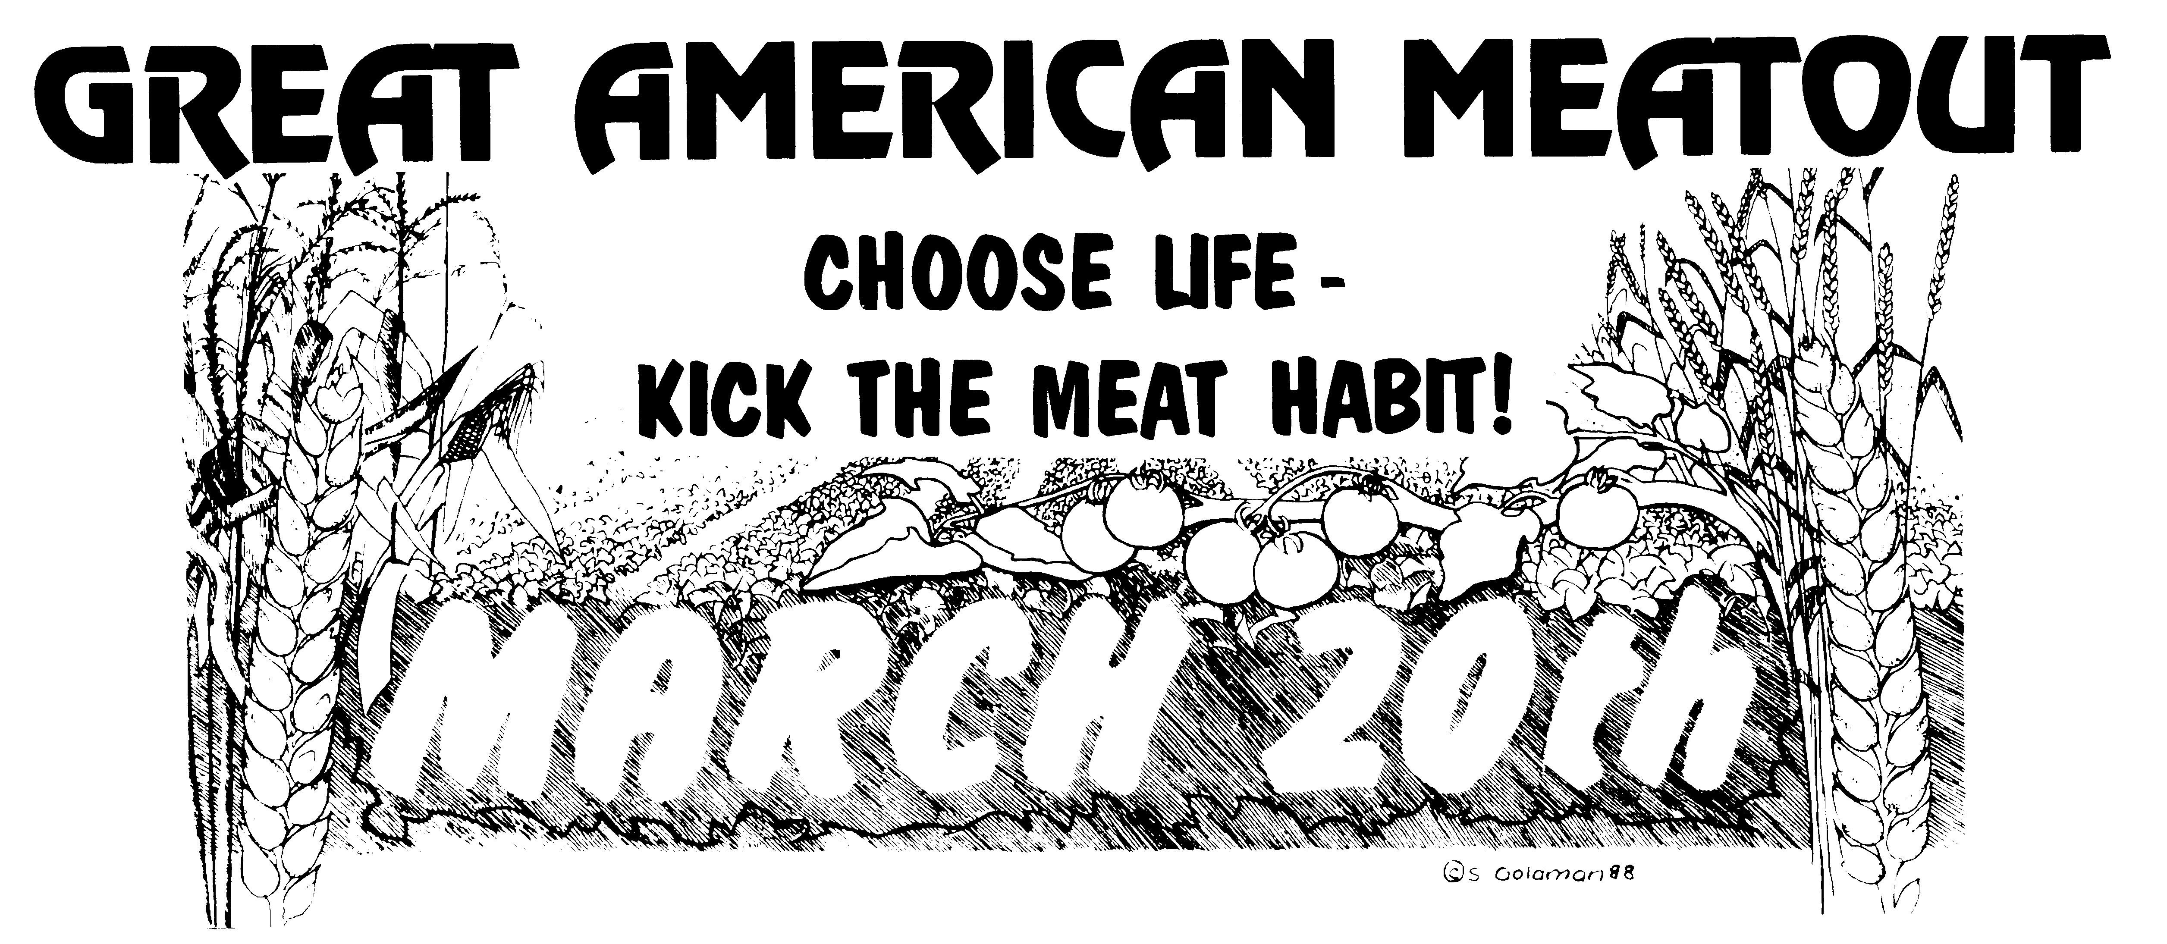

AUGUSTANA VEGETARIAN SOCIETY PRESENTS…

THE GREAT AMERICAN MEATOUT 2006

MARCH 20TH

*Pledge to give up meat for ONE DAY*

Do it for your health, the animals, and the environment.

Sign up during Week 2 in the College Center from 11-1

Then…come watch “Chicken Run” and eat lots of FREE FOOD
in the Andreen Basement on Saturday, March 20th starting at 6 pm

