Enter REQM from the CF\PU\REQ folder or type REQM in the Quick Access box.

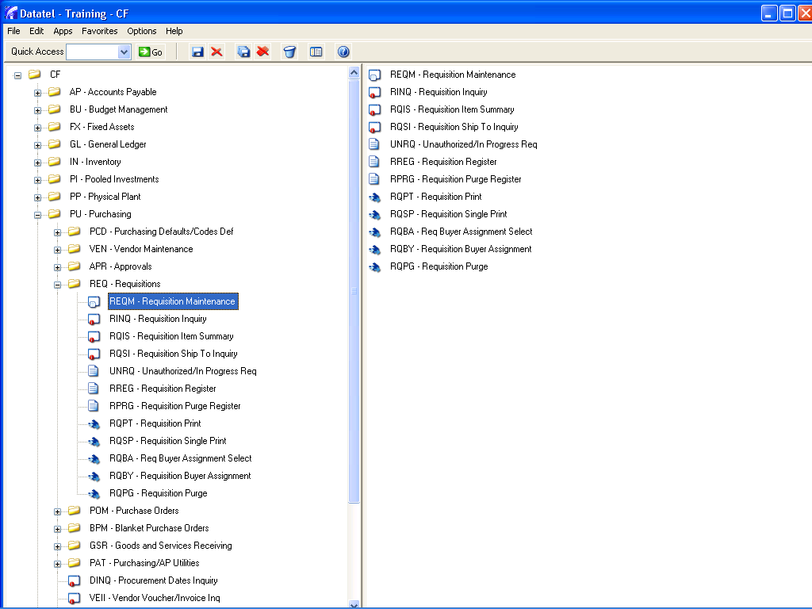

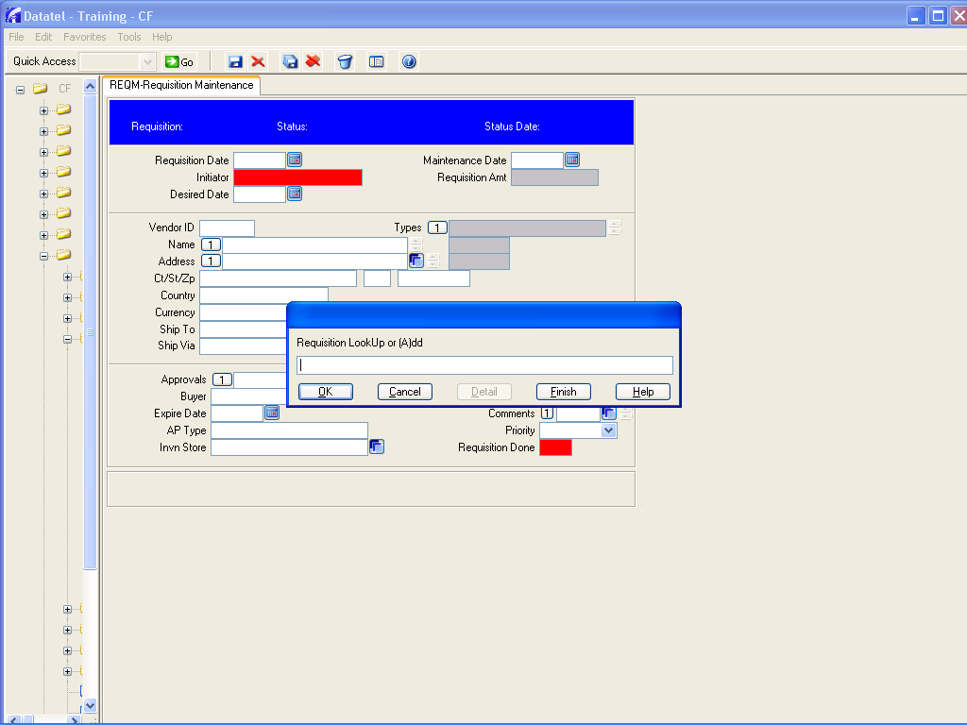
Type a for add and press enter, then at each dialog box press enter (3 more times) and you are into the requisition screen

tab into the red initiator box and type the first few letters of your last name and press enter.
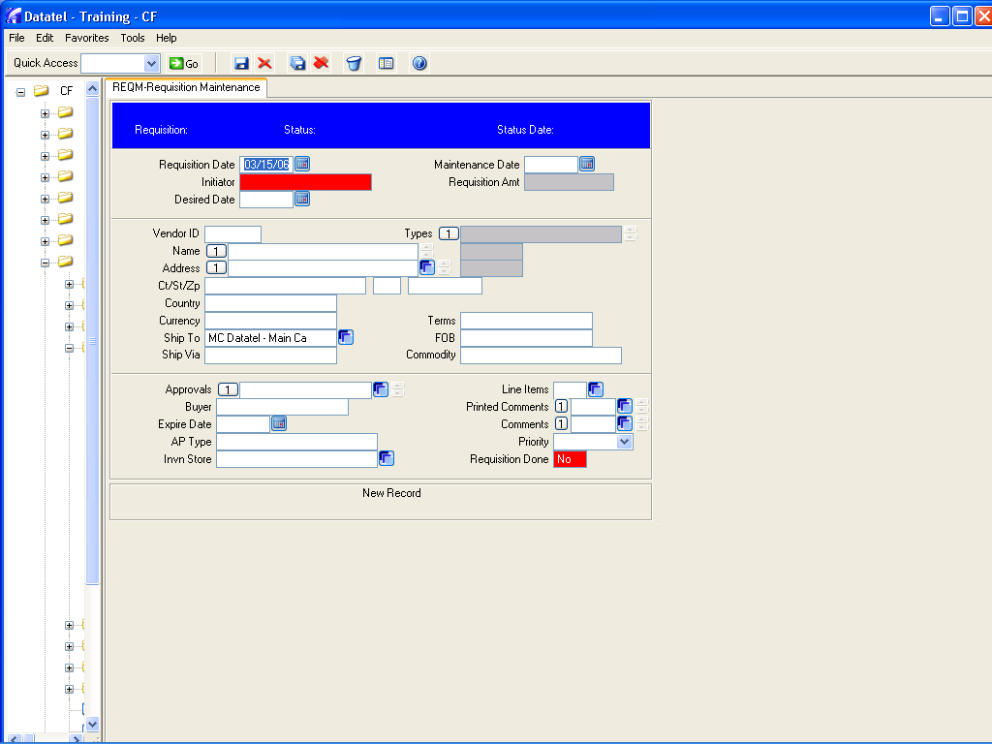
Using the mouse, place a check mark in the box next to the person you want to select and click on the diskette icon or type the number into the box at the bottom and press enter.

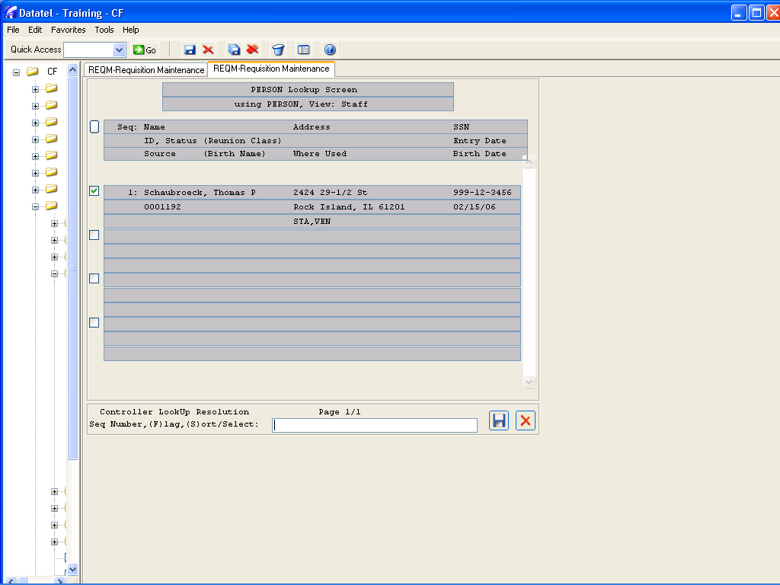

In Vendor I.D. box, type partial vendor name and click enter. Do not try to search on Name field. If you do not know the vendor or do not have a preference you can type just a name in the Vendor name field. This will alert Purchasing to search for the best vendor for these items.

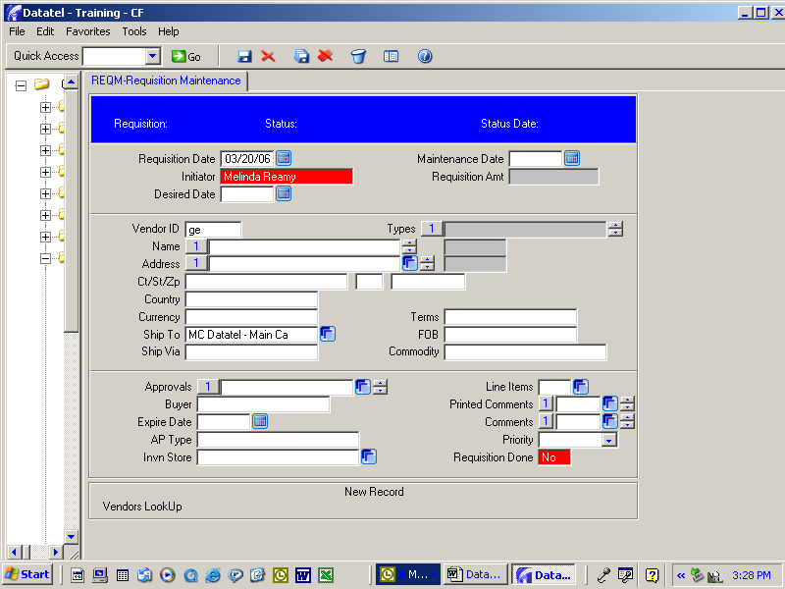

Using the mouse, place a check mark in the box next to the vendor you want to select and click on the diskette icon or type the number into the box at the bottom and press enter

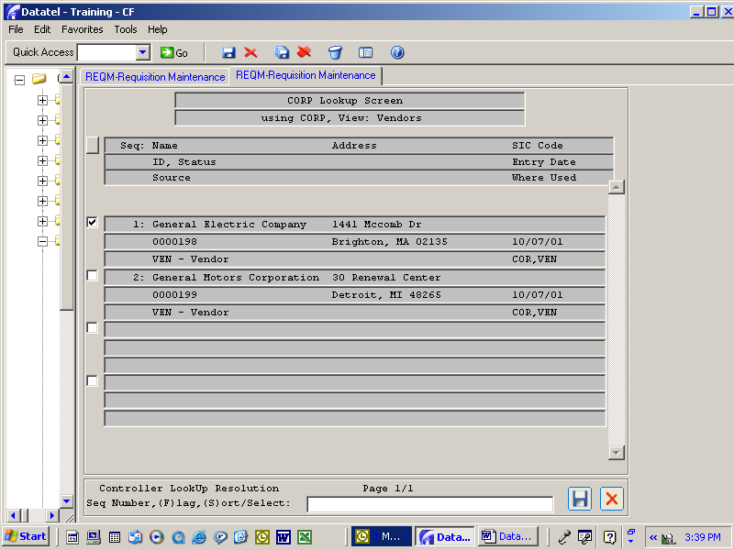

The vendor name and address boxes will automatically be filled in.

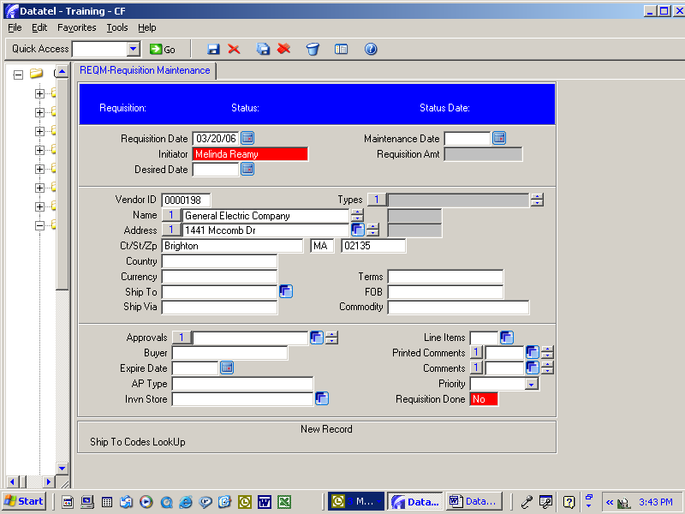

“Country” and “Currency” should default to USA and Dollars.

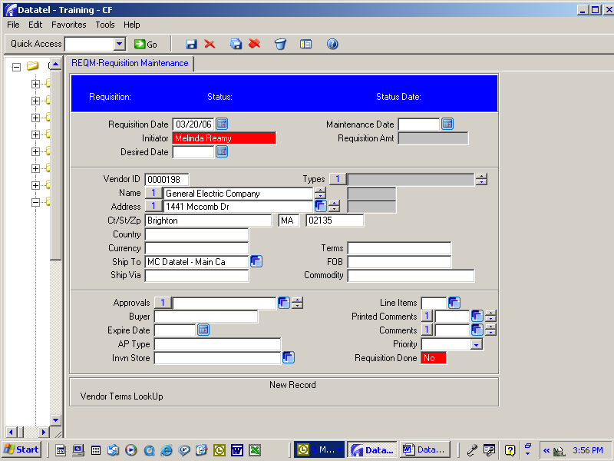

“Ship to” will default to Sorensen Rear Dock, 639 – 38th Street, Rock Island, IL 61201.

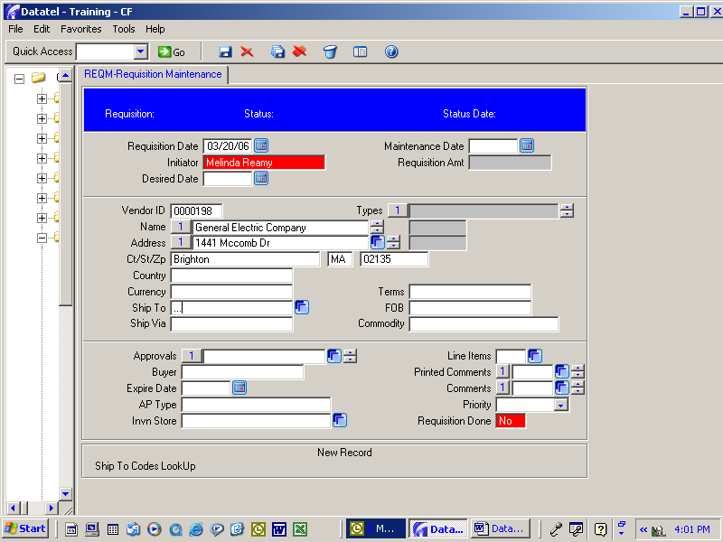

If you need items delivered to Westerlin Food Service, College Center Food Service, or Library, you can type 3 periods such as “…” and in the “Ship to” box and click “Enter” for a choice of destinations.
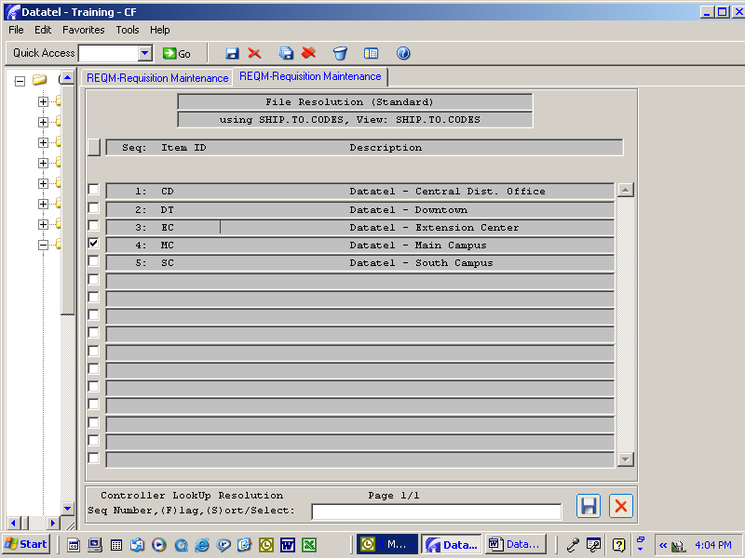

Note: This is not required; however, if the buyer is different than the initiator enter them into buyer box using same method as initiator.

At this point the only other information needed is the item details for what you wish to purchase.Mouse click on the blue square on the right side of the Line Items box

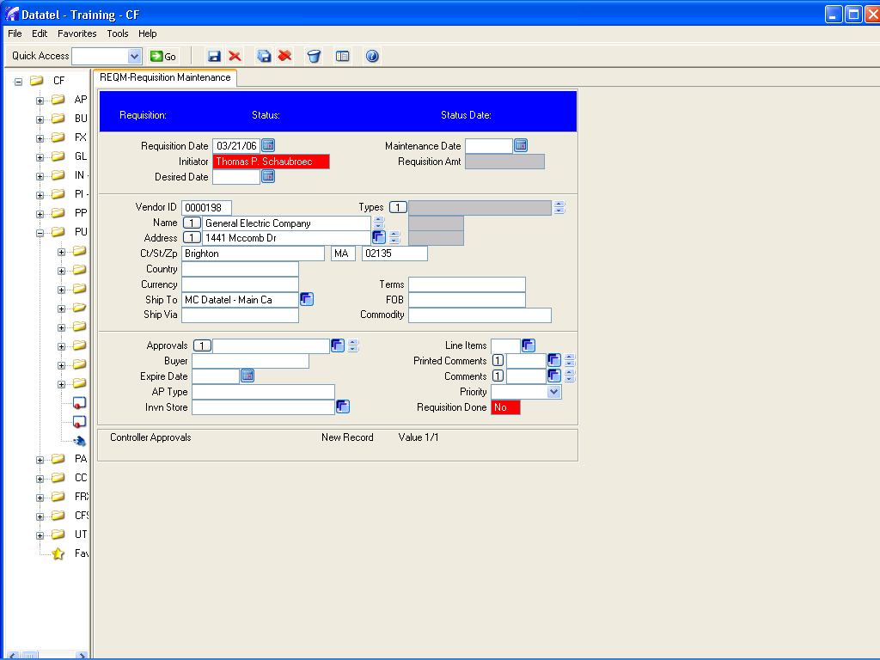

Mouse click on the blue box next to box number 1 to begin entering information for the first line item.
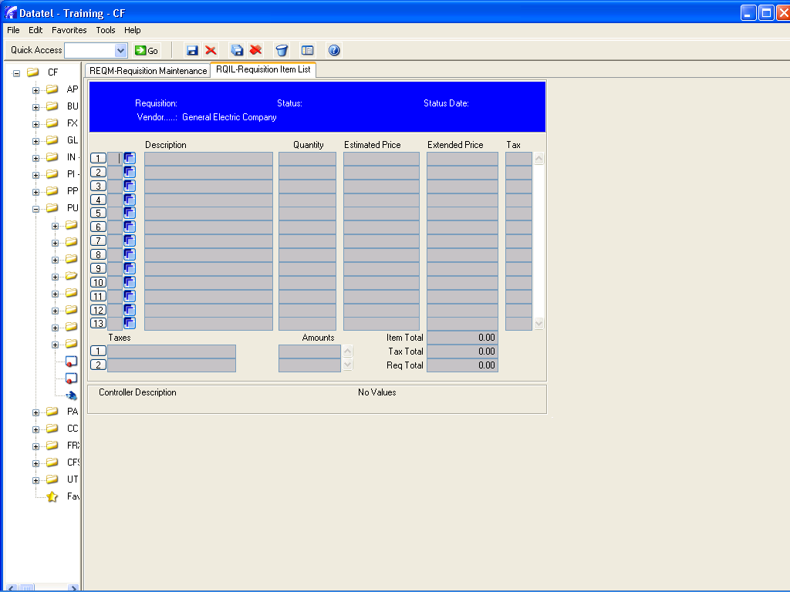

You are now presented with a detail sheet for entering the first item.
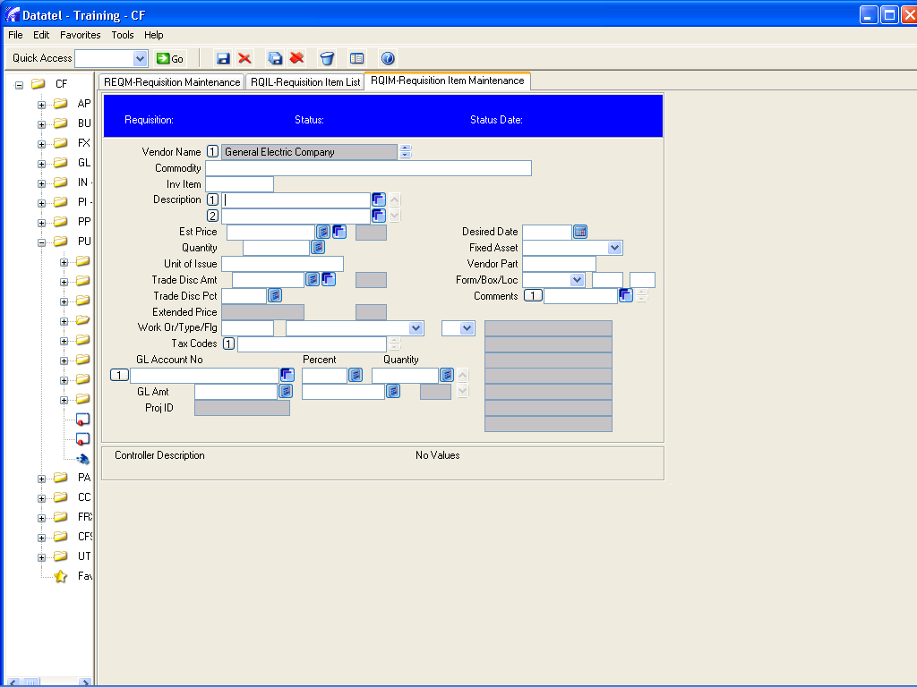

If the description is longer than the first line, click on the blue box to the right and detail into a larger description window.
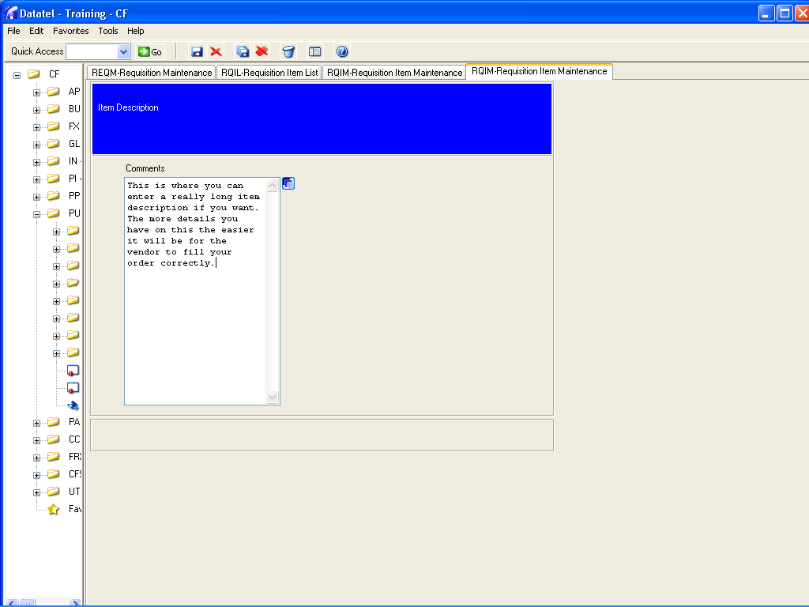

When done with the description, press the small diskette icon up in the menu bar to save and press “update” when presented with that option.
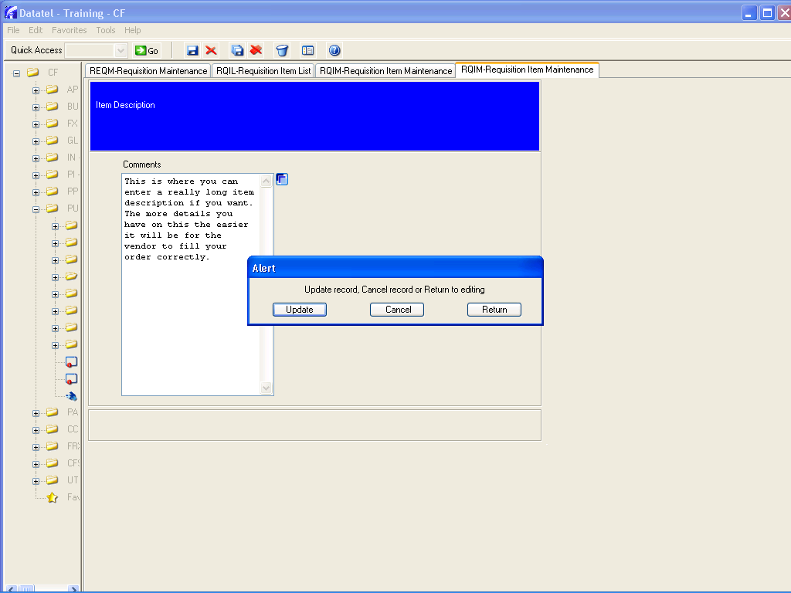

Notice the first part of the description shows up in both line 1 and 2.

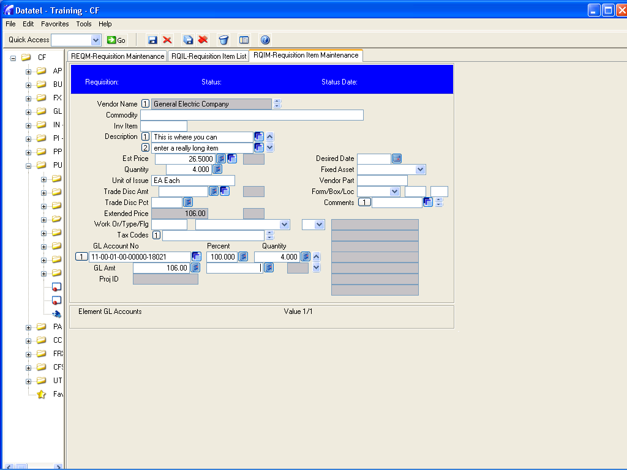

Enter the Est. Price, Quantity, 2 digit code for unit of issue such as ea (each), bx (box) etc. ( … will bring up list)

Enter GL Account No. to be charged. (… brings up your list)
Click on the blank box after GL Amt. and you will notice the Percent, Quantity and GL Amt will fill in automatically.

That’s it you are done. Click the diskette to save and update and you are brought back to theRQIM item detail screen to allow you to enter the next item.
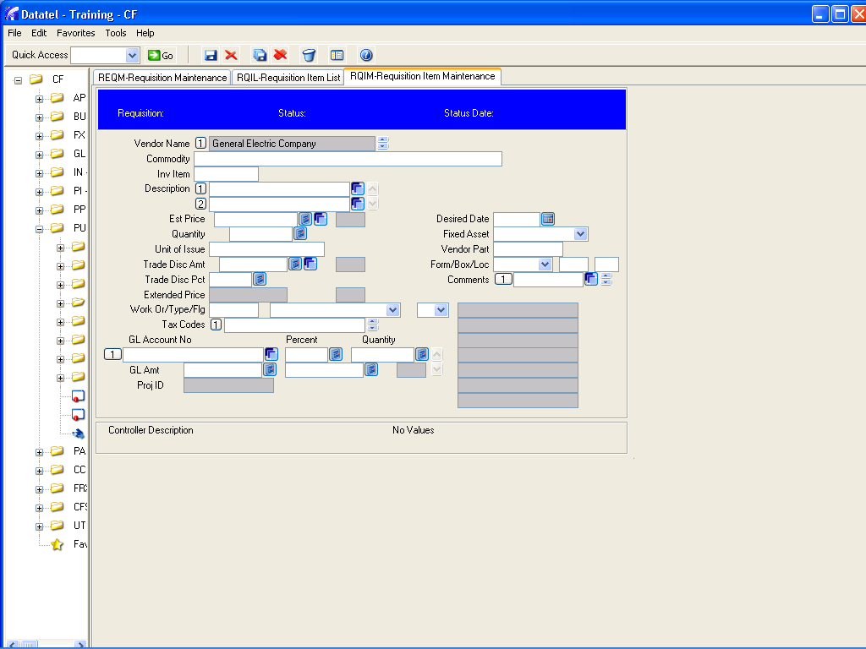
Repeat above steps for each item you wish to order. When done, at this blank screen, click the red X to cancel this screen and return to RQIL - Requisition Item List .

DO NOT Repeat cancel operation at this screen or you will delete your edits. Instead, at this screen you need to click the diskette and do a save and update.

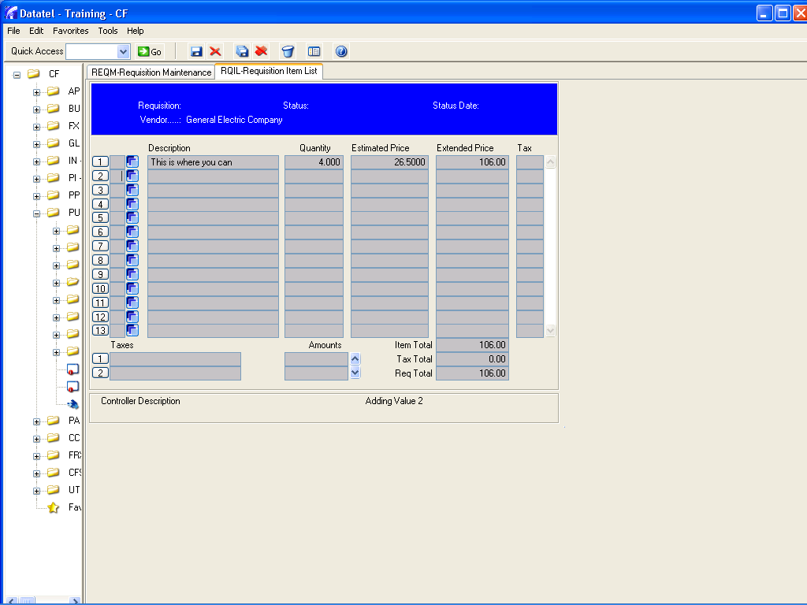

To return you to the REQM main requisition screen.

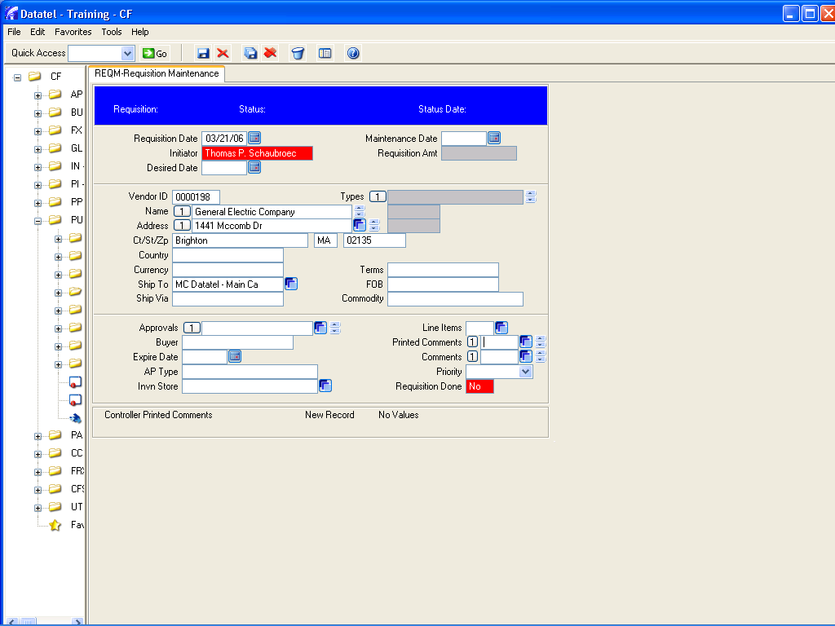

Repeat the save and update process and take note of the requisition number the system has assigned .

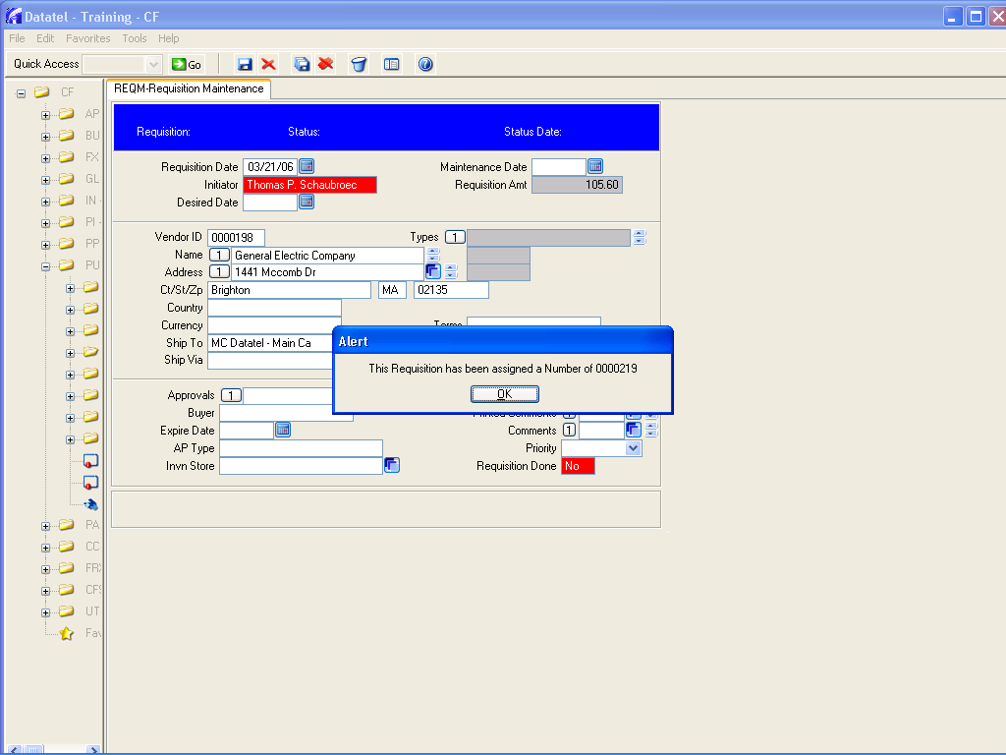
Press OK

you are ready to a (add) another requisition or click finish to exit.

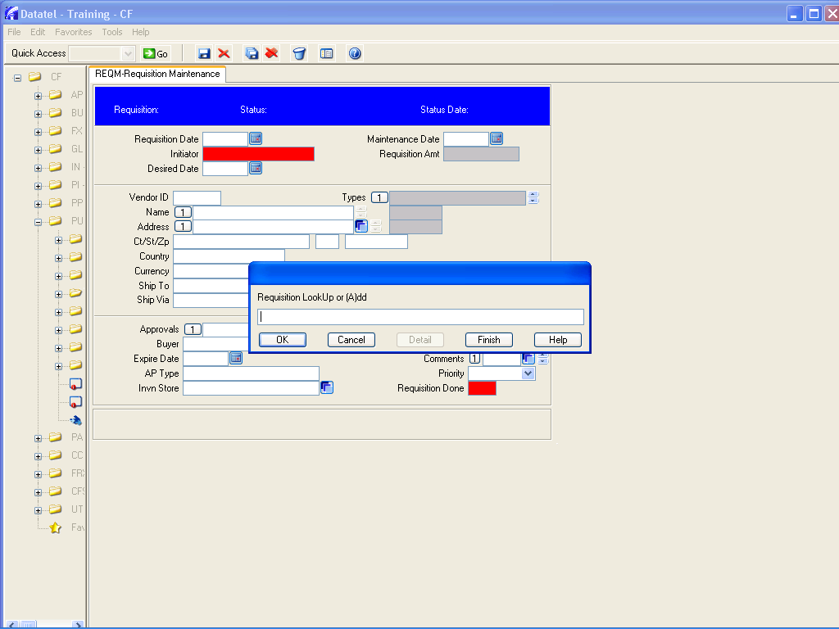

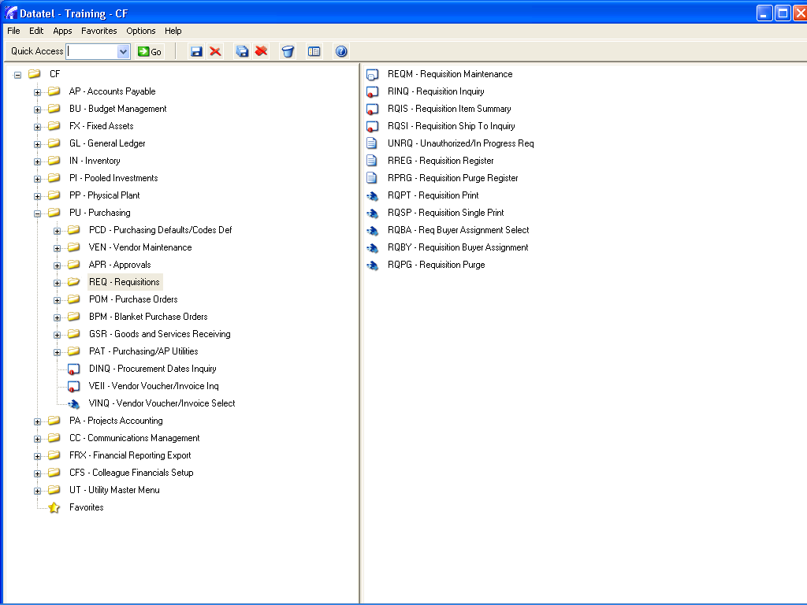

click the red X in the top right corner to exit Datatel.

